**WEEK-2**

**MODULE -3**

**PL/SQL PROGRAMMING**

**SUPERSET ID:6407550**

**Exercise:3-Stored Procedures**

-values inserted to get output

INSERT INTO Accounts (AccountID, CustomerID, AccountType, Balance, LastModified)

VALUES (10, 1, 'Savings', 10000, SYSDATE);

COMMIT;

INSERT INTO Employees (EmployeeID, Name, Position, Salary, Department, HireDate)

VALUES (10, 'Kumar', 'Analyst', 40000, 'Sales', SYSDATE);

INSERT INTO Employees (EmployeeID, Name, Position, Salary, Department, HireDate)

VALUES (11, 'Priya', 'Executive', 45000, 'Sales', SYSDATE);

COMMIT;

INSERT INTO Accounts (AccountID, CustomerID, AccountType, Balance, LastModified)

VALUES (20, 2, 'Savings', 8000, SYSDATE); -- Source

INSERT INTO Accounts (AccountID, CustomerID, AccountType, Balance, LastModified)

VALUES (21, 2, 'Checking', 2000, SYSDATE); -- Destination

COMMIT;

**Scenario:1**

CREATE OR REPLACE PROCEDURE ProcessMonthlyInterest IS

BEGIN

FOR rec IN (

SELECT AccountID, Balance

FROM Accounts

WHERE AccountType = 'Savings'

) LOOP

UPDATE Accounts

SET Balance = Balance + (rec.Balance * 0.01),

LastModified = SYSDATE

WHERE AccountID = rec.AccountID;

DBMS_OUTPUT.PUT_LINE('✅ Interest applied to Account ID ' || rec.AccountID);

END LOOP;

COMMIT;

END;

**/OUTPUT:**

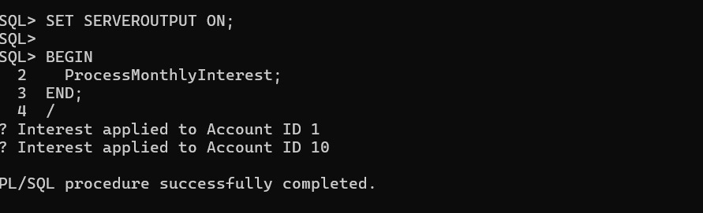

**Scenario:2**

CREATE OR REPLACE PROCEDURE UpdateEmployeeBonus(

p_Department IN VARCHAR2,

p_BonusPercent IN NUMBER

) IS

BEGIN

FOR rec IN (

SELECT EmployeeID, Salary FROM Employees WHERE Department = p_Department

) LOOP

UPDATE Employees

SET Salary = Salary + (rec.Salary * p_BonusPercent / 100)

WHERE EmployeeID = rec.EmployeeID;

DBMS_OUTPUT.PUT_LINE('✅ Bonus applied to Employee ID ' || rec.EmployeeID);

END LOOP;

  COMMIT;

END;

**/**

**OUTPUT:**

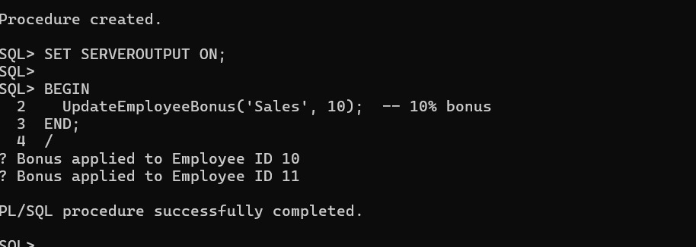

**Scenario:3**

CREATE OR REPLACE PROCEDURE TransferFunds(

p_FromAccountID IN NUMBER,

p_ToAccountID IN NUMBER,

p_Amount IN NUMBER

) IS

v_Balance NUMBER;

BEGIN

SELECT Balance INTO v_Balance FROM Accounts WHERE AccountID = p_FromAccountID;

IF v_Balance < p_Amount THEN

RAISE_APPLICATION_ERROR(-20001, 'Insufficient funds in source account.');

END IF;

UPDATE Accounts SET Balance = Balance - p_Amount WHERE AccountID = p_FromAccountID;

UPDATE Accounts SET Balance = Balance + p_Amount WHERE AccountID = p_ToAccountID;

COMMIT;

DBMS_OUTPUT.PUT_LINE('✅ Transfer completed successfully.');

EXCEPTION

WHEN OTHERS THEN

ROLLBACK;

DBMS_OUTPUT.PUT_LINE('❌ Transfer failed: ' || SQLERRM);

END;

/

**OUTPUT:**

